**Bash Scripting - 01**

**Name: Rakesh – 15**

**BASIC COMMAND SCRIPT**

1. Creating a commands file for executing 6 script commands & give permissions to file commands.bash

* Pwd - here it shows the present working directory
* Ls - list of files
* Whoami - it has given root directory
* Date – It has given present date and time
* Cal- it has given calender

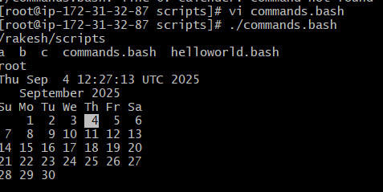

**BASIC ADMINISTRATION SCRIPT**

1. Creating a file named as vi admin.bash need to write the commands, Then need to change the permissions as chmod 755 admin.bash then we need to execute the output shows like

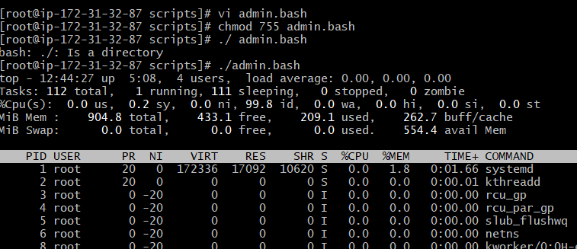

**DEFINE VARIABLE**

1. Create a files as variables.bash and ask the permission to the file then execut it

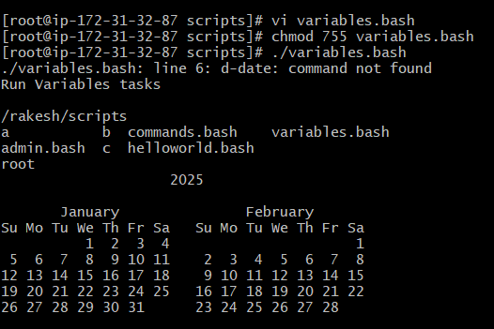

**INPUT / OUTPUT SCRIPT**

1. Create a file as vi input.bash

* Here, it takes the input from the user and ask the permission from chmod 755 input.bash
* Then it display the output

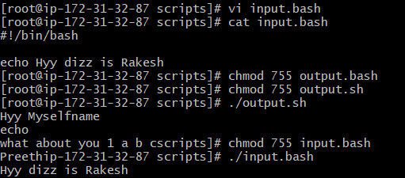

1. Create a file using vi output.sh

* Give the host names and ask the permission chmod 755 output.sh
* And get the output

